**Speedball**

**(Adapted from** [**Wikipedia**](http://en.wikipedia.org/wiki/Speedball_(sport))**)**

**What is the game of *Speedball* ?**

**Speedball** is a quick, fast paced sport that is simple to teach and combines many aspects of other sports. The goal of the game is to throw the ball into a goal, kick the ball into a goal, or shoot a basket. It is played with two teams of five, each with one goalkeeper on a basketball court or football/soccer field. It is a combination of the three sports of football, soccer, and basketball.

**What is the history of *Speedball*?**

* Invented by Elmer Mitchell at the University of Michigan in 1921
* Created for physical education classes as well as intramurals
* Game was created:
  + To involve different skills
  + Was inexpensive
  + Played by people of different athletic abilities
* Combination of:
  + Soccer
  + Basketball
  + Football

**What is the object of *Speedball*?**

* Score as many points as possible in the time given. The team with the most points wins the game

**What is a *Speedball*  court look like?**

**How do you play *Speedball*?**

G

O

A

L

G

O

A

L

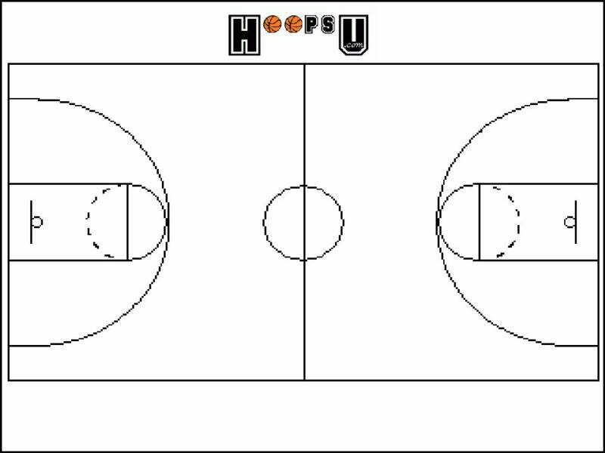

**The Field:**

* Generally played on a basketball court. (can be played on a soccer field)

**Scoring:**

* Throw = 1 point
* Kick = 2 points
* 3 Point Basket = 3 points

**Teams:**

* Generally played with 5 vs. 5 (4 "field" players, and 1 goalie)
* If there are extra people, they can be used as substitutes OR the team sizes can simply be expanded (if one does play with subs, unlimited substitutions are allowed)

**Gameplay:**

* Game starts by having a **jump ball** in the center of the court
* When the ball is on the ground it is played like soccer
* When the ball is in the air played like football and/or basketball
* The field players are allowed to move anywhere on the field of game play
* The field players are permitted to touch the ball with any part of their body at any time EXCEPT their arms/hands (see next rule for details)
* Field players may use their arms/hands as long as the last thing the ball touches is not the ground; one may NOT pick up the ball from the ground or catch it after it bounces off the ground.
* **Conversions**: acceptable skills to change the play from soccer (on the ground) to football/basketball (in the air)
  + Player kicks the ball in the **air** and has a teammate catch it
  + Players uses their foot to move the ball up a wall
  + Player sticks the soccer ball in between their feet and completes a “self-kick”
  + If the ball is kicked or thrown off the wall and caught **before** it hits the ground
* If a player does touch the ball with their arms illegally, then it is considered a handball penalty and will result in the ball being turned over to the other team
* If the player has the ball in his/her hands, they are allowed **2 steps**
* Once a player has a ball in their possession, they can pass it off, attempt to score, or drop the ball in order to play soccer to move the ball
* Goalies can touch the ball with ANY part of their body, meaning that they have the power to pick up the ball off the ground without it being considered an "illegal" move inside their goalie box (the three point arch)
* Once the goalies leave their box, they are considered a field player and must adhere to the rules

**Violations and/or Penalties:**

* All penalties result in turning the ball over to the other team
* **Handball** — if a field player touches the ball with his/her hands after it touches the ground
* **Traveling** — when any player takes more than 2 steps
* **Unsportsmanlike Conduct** — viciously assaulting another player with no intention of going after the ball
* **Holding** – if a player holds the ball for more than 5 seconds