Floor/Ball Hockey

(adapted from wikipedia)
What is the game of Floor/Ball/Dek Hockey?
Ball hockey is a team sport and a variation of the sports of ice hockey and street hockey, where the game is played on foot in which players use sticks to direct a ball into their opposing team's net. When that occurs it is referred to as a "goal". At the end of the time allotted for the game the team with the highest number of goals is declared the winner. In some places, mainly in the United States, ball hockey is also called "dek hockey", though organized ball hockey and dek hockey leagues do have slightly different rules and play on different sized official rinks.
What is the history of Floor/Ball/Dek Hockey?
The exact origin of hockey is hard to pinpoint. Some people say it started from hurling – an Irish game similar to lacrosse. Others say it came from the English game of field hockey-when the English came to North America they realized that they could move faster on the ice covered ponds than the grass, so they started playing ice hockey. The name “hockey” may be from the French word “hocquet” meaning “Shepherd’s Crook”, which is the shape of a hockey stick.
What is the object of Floor/Ball/Dek Hockey?
At the end of the time allotted for the game the team with the highest number of goals is declared the winner.
What is a Floor/Ball/Dek Hockey court?
At the highest levels of ball hockey, teams will play against one another in an ice hockey rink minus the ice. There are three different lines in hockey and three playing zones. Lines = 2 blue lines, 2 goal lines, and a center line (red line). Zones = Defending Zone, Neutral Zone, Attacking Zone.
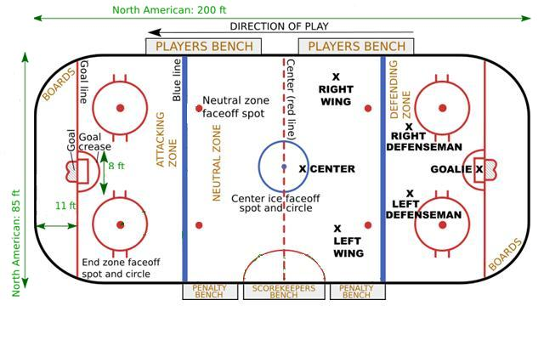

What equipment is used in Floor/Ball/Dek Hockey?
Equipment: At the highest levels of ball hockey, players wear shin guards/pads that one would normally associate with soccer, though specific guards for the sport of ball hockey have been developed and are manufactured and sold to ball hockey players. Most male players also wear an athletic cup for groin and genitalia region protection. Players do not wear shoulder pads, but sometimes wear forearm protection. Each player uses a standard ice hockey stick.
The Ball: At the highest levels of ball hockey, teams use a hard, orange, small, round, and smooth orange/reddish ball. This allows for players to make the ball curve by over/under exaggerating a windup and follow through on their shots.
Goalie equipment: At the highest levels of ball hockey, goalies use almost the same equipment as ice hockey goalies.
What are the positions in Floor/Ball/Dek Hockey?
There are 6 total players on the ice for each team.

In hockey there are three main positions, forward, defense, and goalie. The forwards include left wing, center, and right wing. The defense includes left defenseman and right defenseman; and of course there is the goalie.

How do you play Floor/Ball/Dek Hockey?
CBHA Basic Rules
• Face-offs (players are lined up facing each other in a designated area on the floor), are used at the start of each period of play and after goals, penalties, icing, offside, or when the ball leaves the playing area.
• Penalties are called when a player commits a foul. The offending player is then removed from playing for a period of time, depending on the severity of the infraction and the team continues play one player short until the penalty has elapsed. High Sticking: A penalty in which the stick is raised above shoulder level (real hockey) or hip level (for PE). Infractions can result in 2 or 5 minute suspensions from the game.
• When an offside occurs Play is stopped. Before entering an opponent team's zone (the area from behind their net to their blue line) the ball must cross the blue line first before the player or any of his teammates.
• Icing (or flooring) occurs when a team shoots the ball before the shooting player physically crosses the center line and the ball passes the opponent's goal line before any player, of either team, can touch it. A stoppage of play shall occur with the ensuing faceoff taking place in the end zone of the team that shot the ball. If the goalie touches the ball, or the shot creates a goal, there is no icing on the play.
• To score a legal goal, it cannot be kicked in; nor struck with a stick above the shoulders; nor pushed in using the hand, nor while offside.
Games may vary in length, but are generally played with either two or three periods of equal time, example 10 or 15 minute periods. If a clock is not available, or the time available to play is limited, running time periods may be used, for example three 15 minute periods.

Important and Helpful Links
Ball Hockey USA
Street Hockey USA
USA Floorball

